
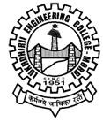
A REPORT on SSIP Sensetization Programme
Chemical Engineriing Department
Date: 2nd February, 2024
The Sensitization programme on “SSIP” was held by Chemical Engineering Department1st, 2nd & 3rd year students on 2nd February, 2024 at Chemical Engineering Department, Lukhdhirji Engineering College-Morbi. Approx. more than 104 students had attended the same. Department SSIP Coordinator Dr. Ashish Baldania had elaborate SSIP in brief, how it’s beneficial for students and also discussed future planning of making success of SSIP.
Glimpses: (put 2-4 pics with caption)
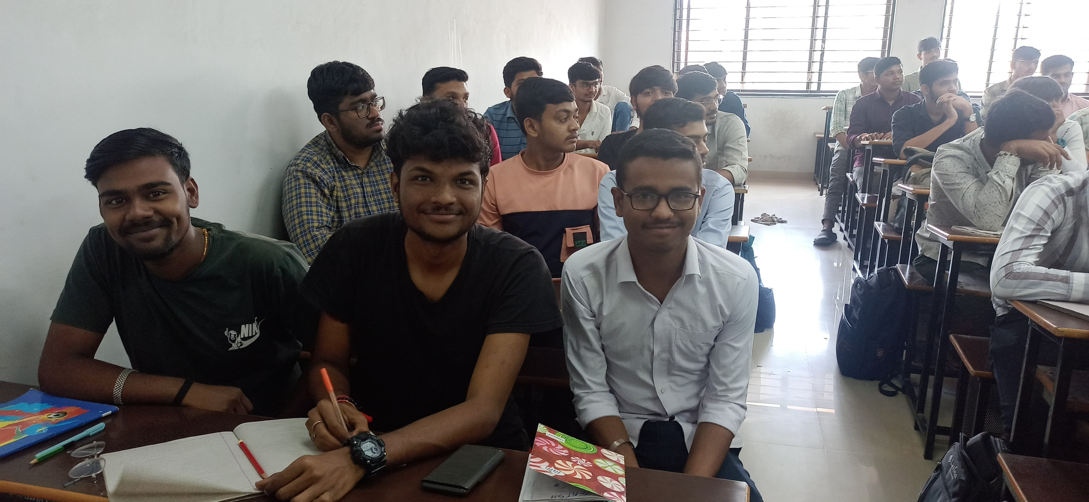 | 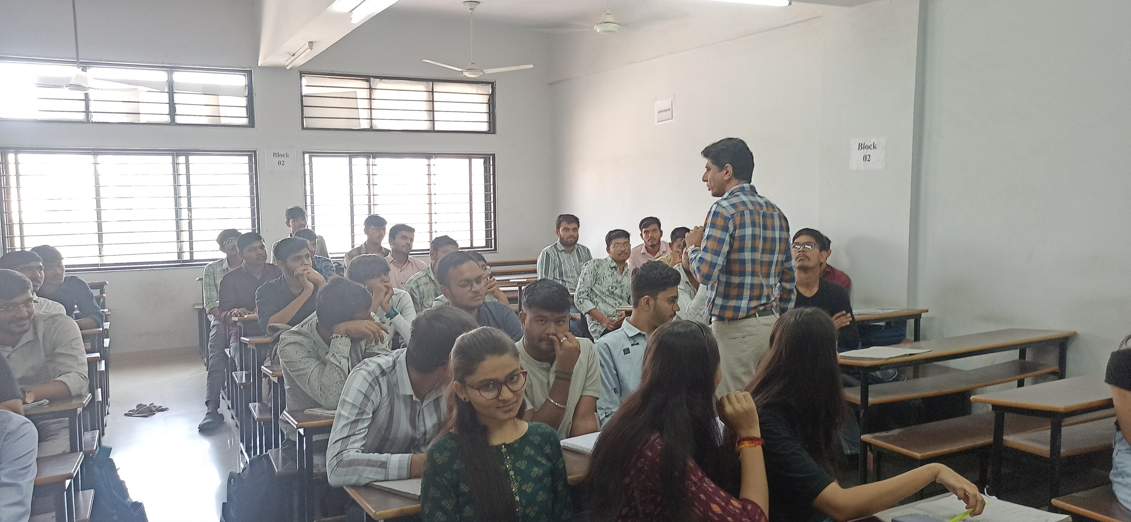
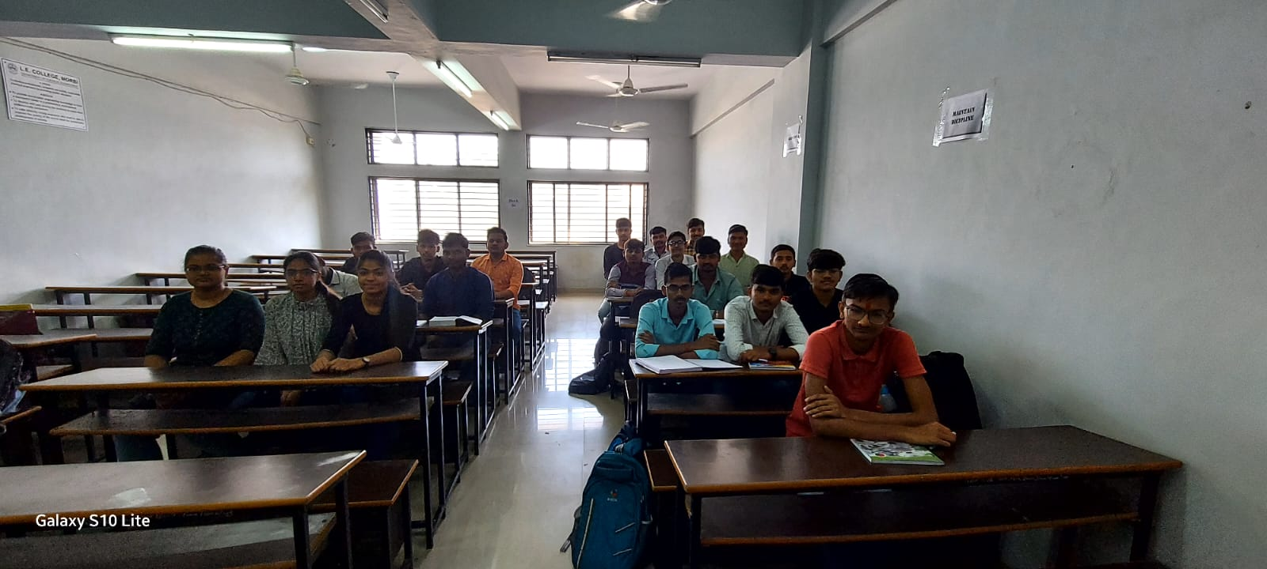 | 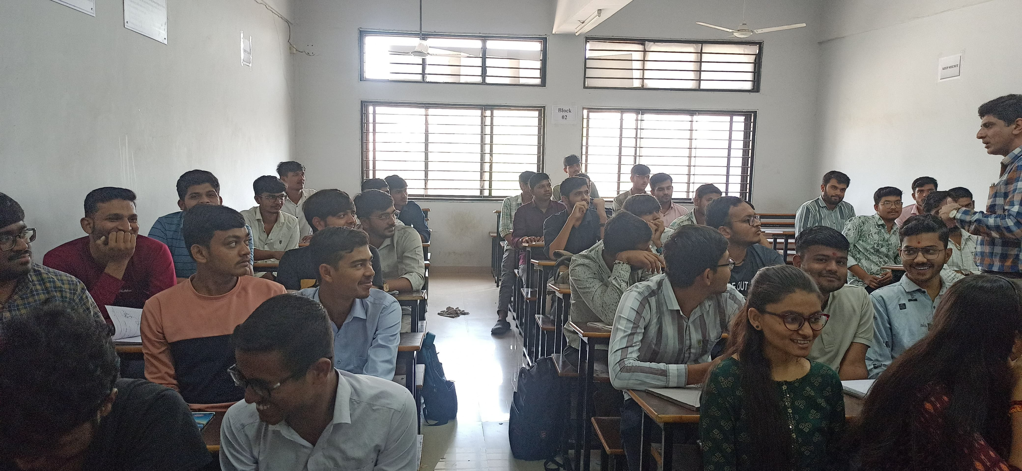

Activity/Event Coordinator (name and sign) HOD (sign & stamp)
Dr. Ashish Baldania

